- Uninstalling jdk 1.8

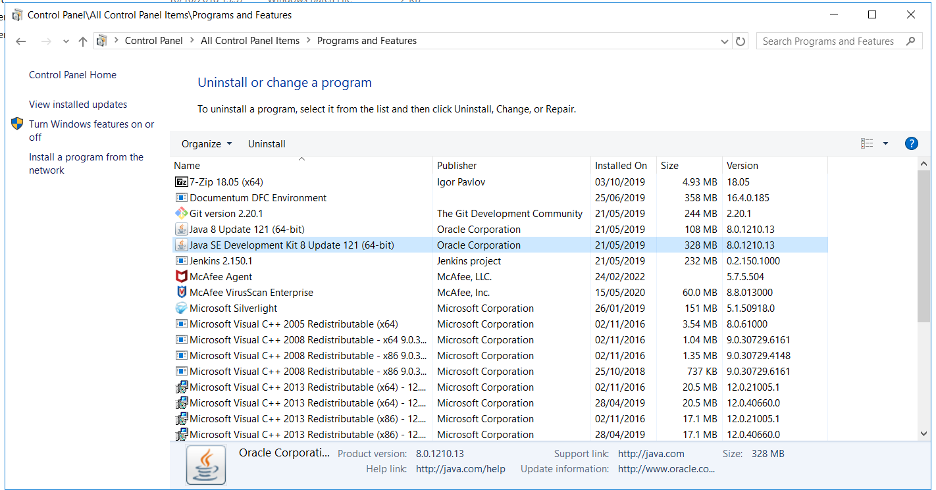
Backup 16.4 related software to New Folder “C:\Software_backup_before_upgrade”
Copy 21.4 related software from \\cfs\COE_Documentum\omr upgrade\21.4\Softwares\windows to C:\ or D:\software\21.4

- Extract the zip file to C:\ and maintain like below ( Delete the zip folder or any additional folder created)
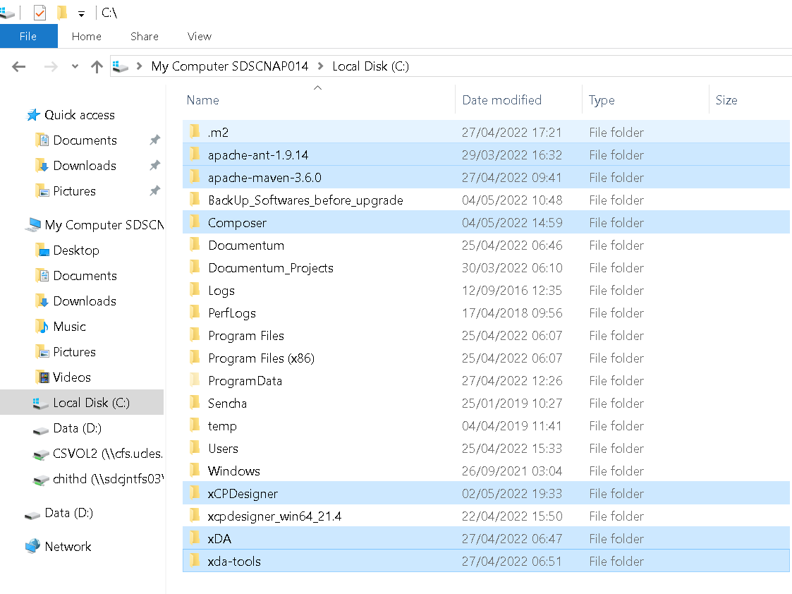

- Installing jdk 11.2

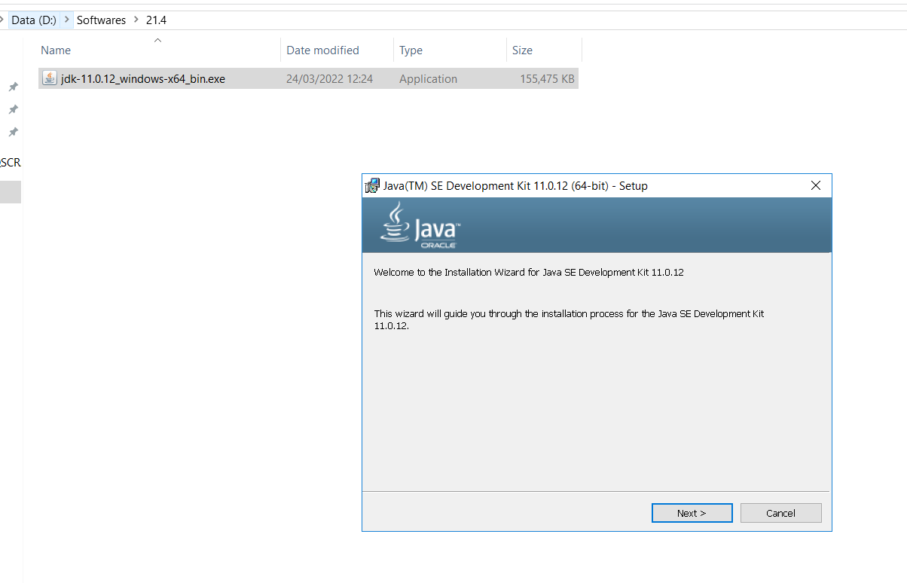

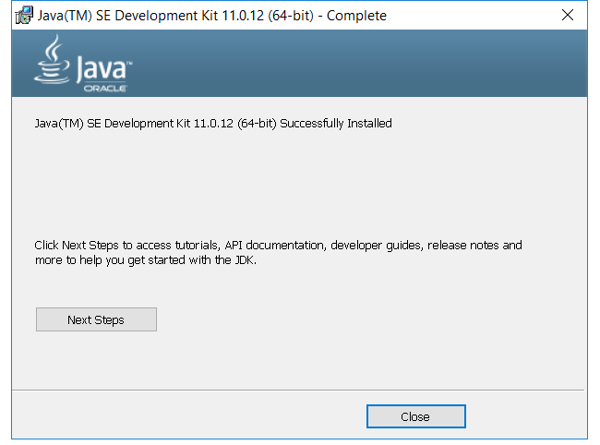

- Update the environment variables
Java_home, Ant_home, Maven_home, M2_Home

- ?* Removed below line from C:\ant\bin\ant.bat
set JAVA_HOME=%JAVA_HOME_ANT%
set PATH=%JAVA_HOME_ANT%\bin;%PATH%
- C:\Composer\plugins\com.emc.ide.external.dfc_1.0.0\documentum.config\dfc.properties
Update the dfc properties
- C:\xda-tools\config\xda.properties
xda-host = sqscrap740
xda-port = 7000
xda-schema = http

- Install xda as window service

- Stop the xda services.
- Log in to the Windows machine as an administrator user.
- At the ${xda-home}\bin prompt, use this command to uninstall xDA service:
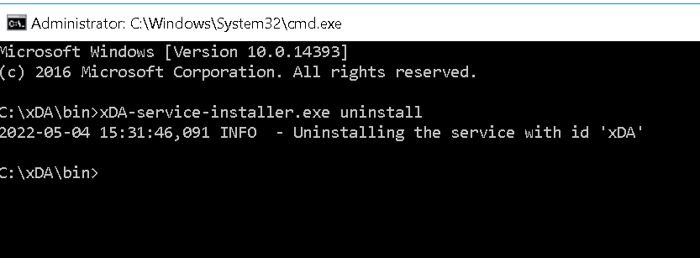
xDA-service-installer.exe uninstall

- Installing the Xda

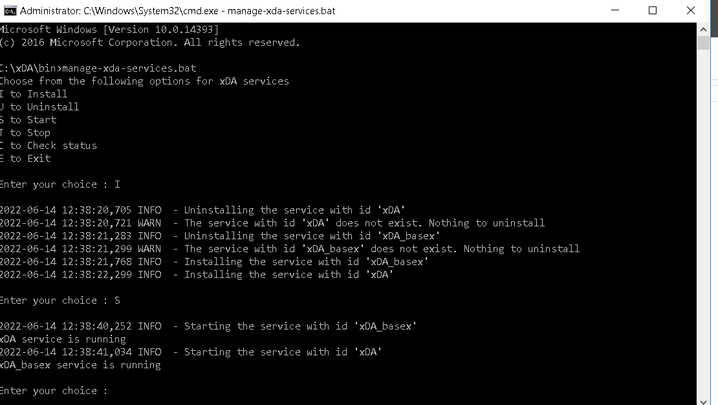

To start xDA service:
Click Start > Programs > Administrative Tools > Services.
Select Documentum xCP Deployment Basex Agent service and click Start service.
Select Documentum xCP Deployment Agent service and click Start service. •
To stop xDA service:
Click Start > Programs > Administrative Tools > Services.
Select Documentum xCP Deployment Agent service and click Stop service.
Select Documentum xCP Deployment Basex Agent service and click Stop service.

- Set xda admin password

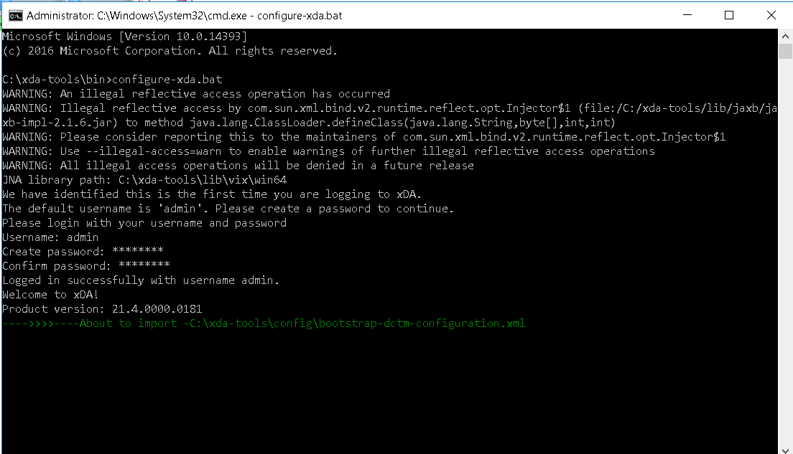

- Upgrade Jenkins

- Uninstall existing Jenkins
- Install Jenkins 2.345 from D:\Softwares\21.4\jenkins2.3

Stopping the services of Jenkins

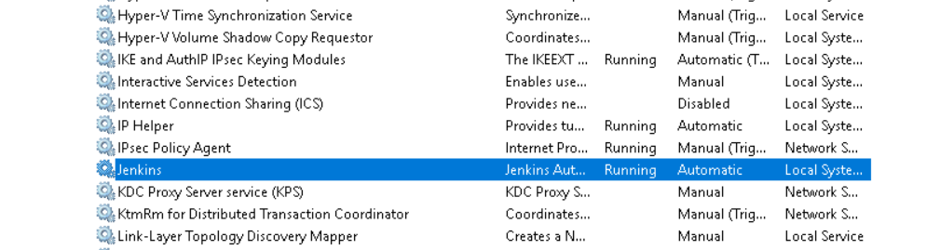
Uninstalling Jenkins

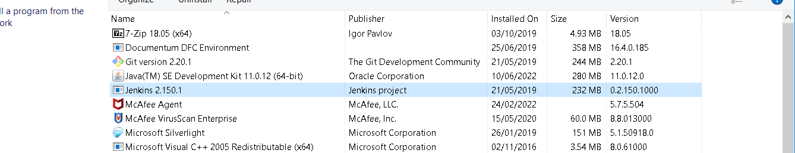

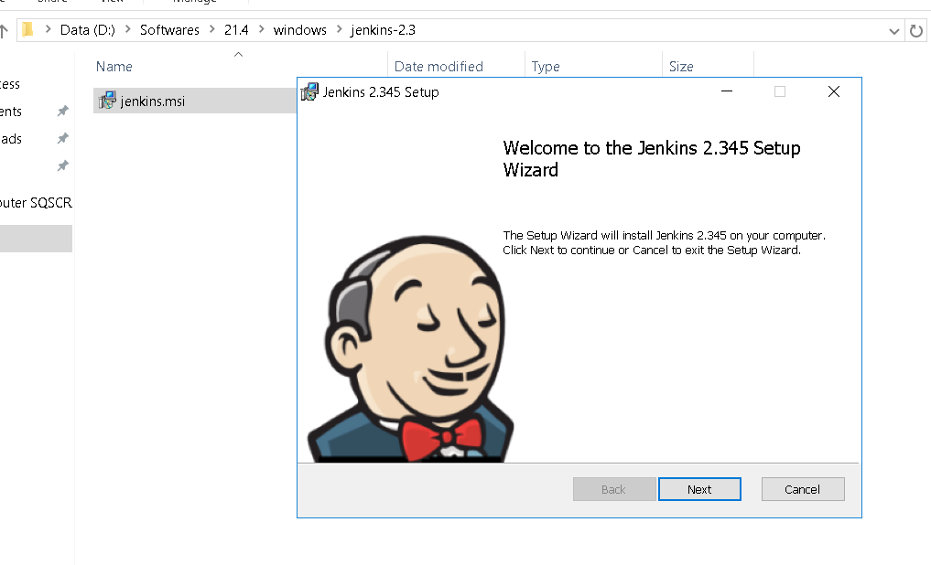

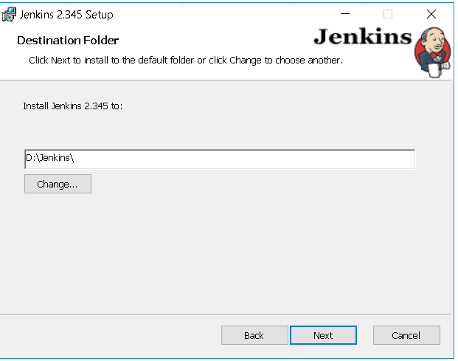

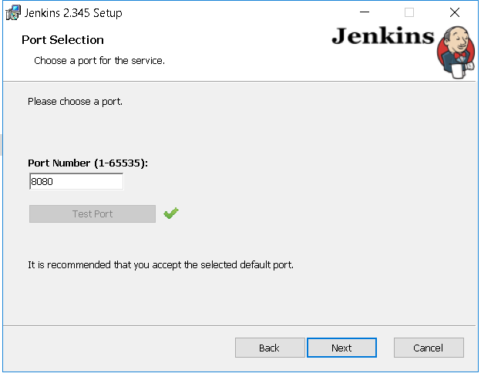

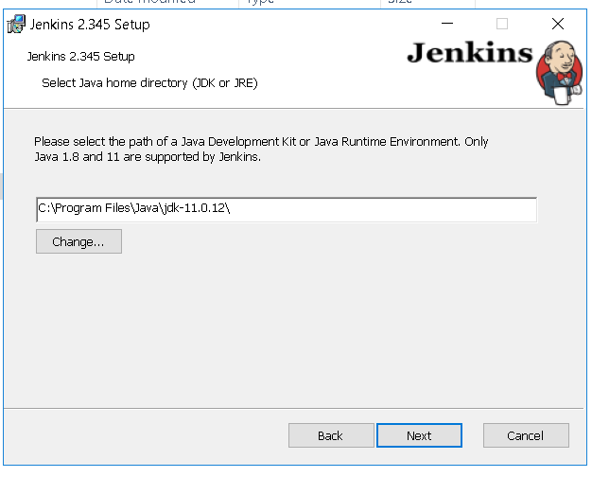
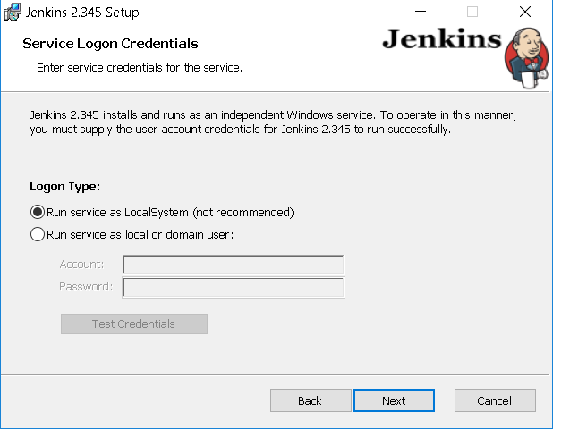

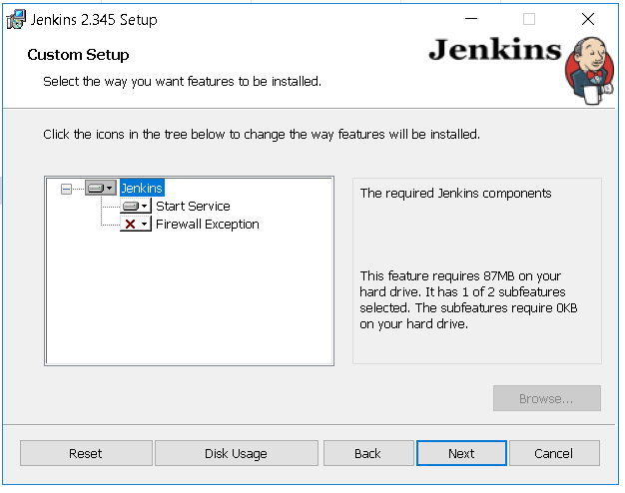
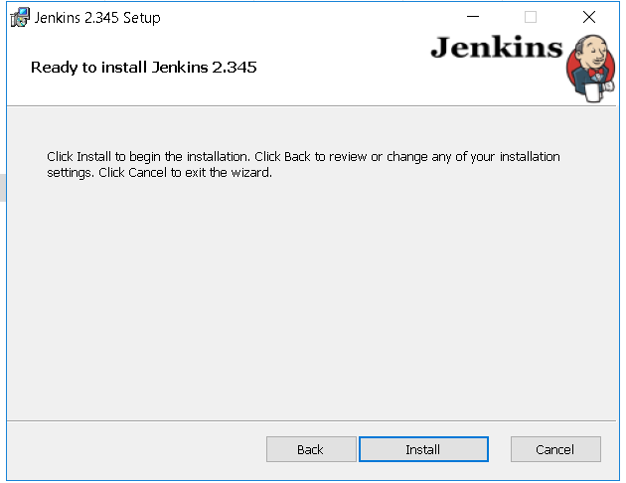

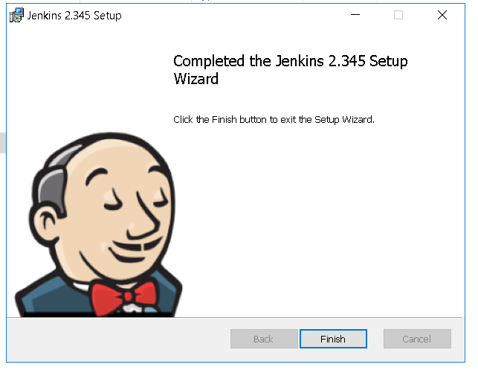

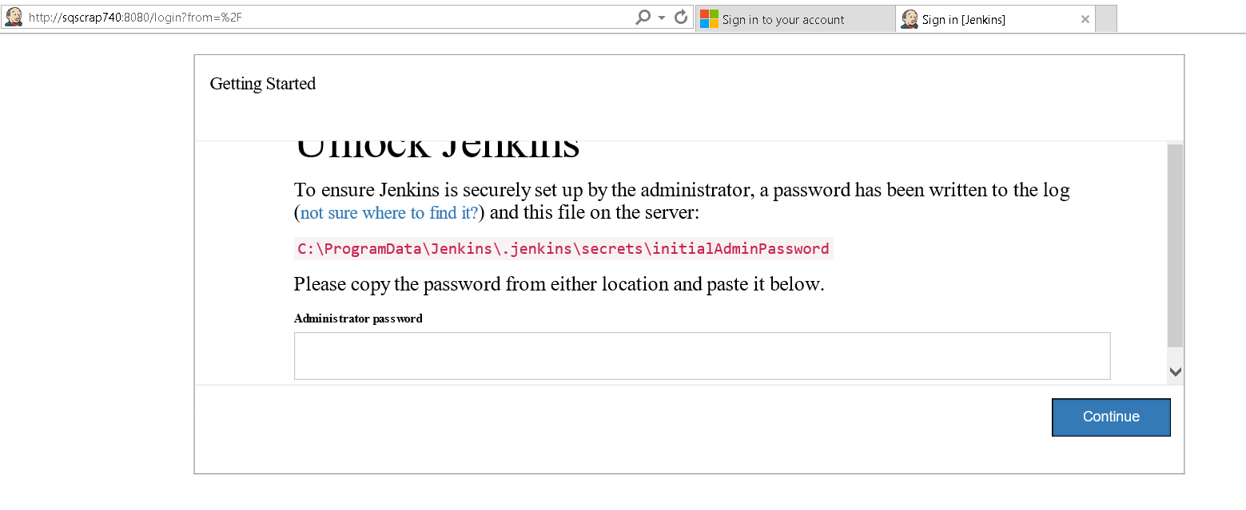

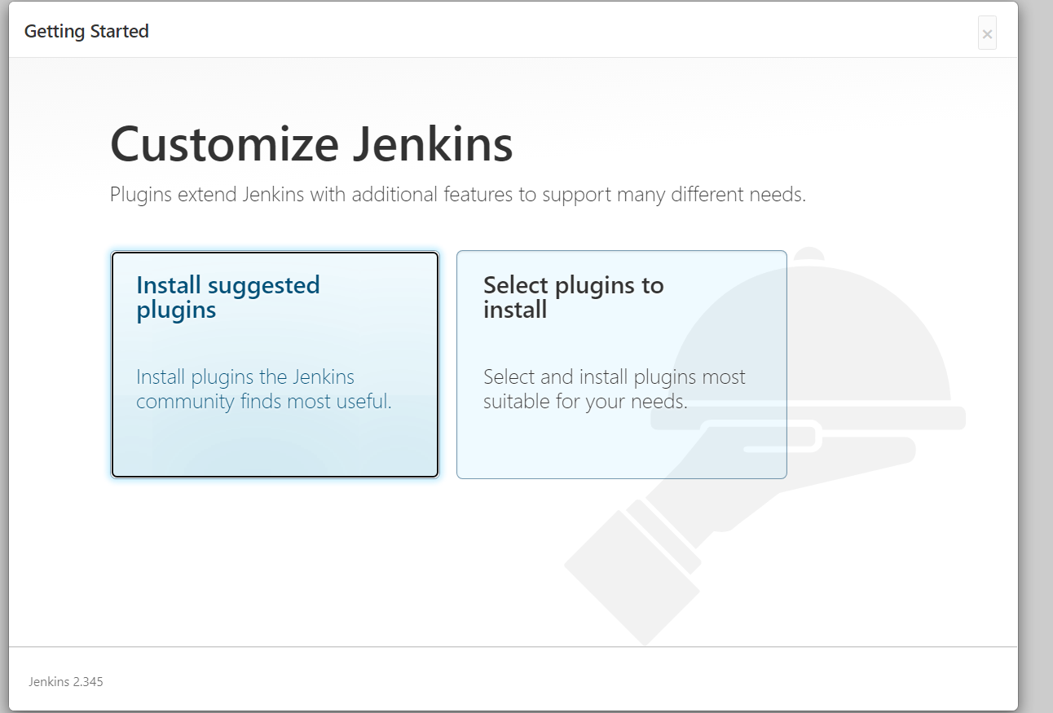

We select the first option.
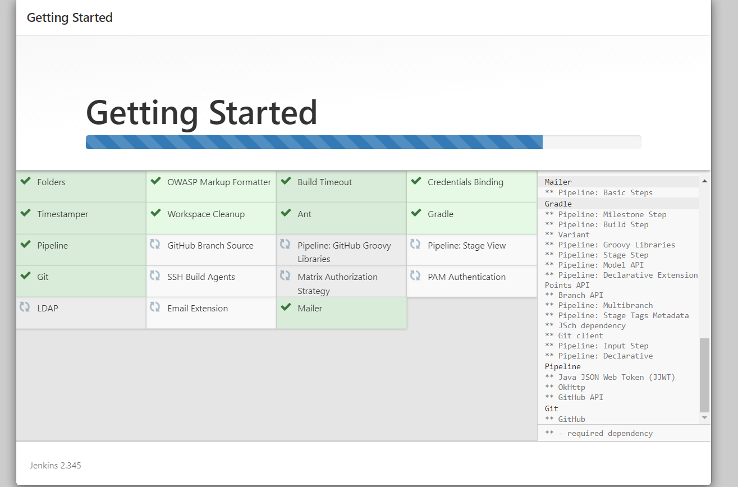

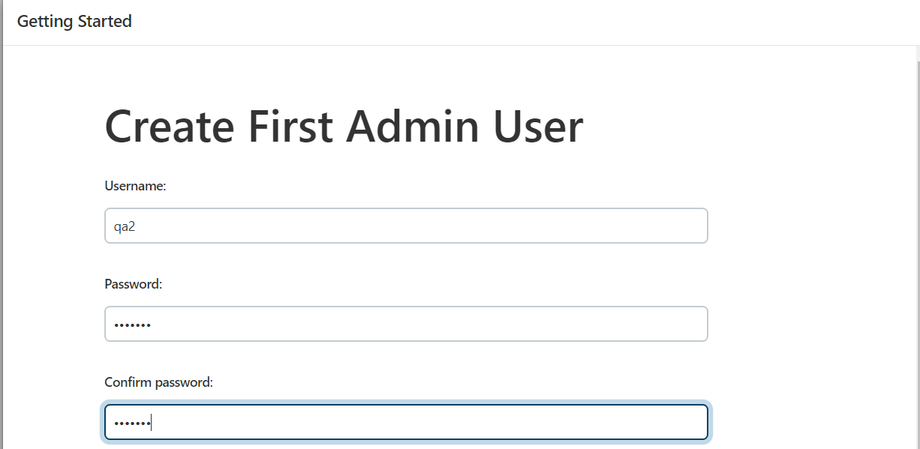

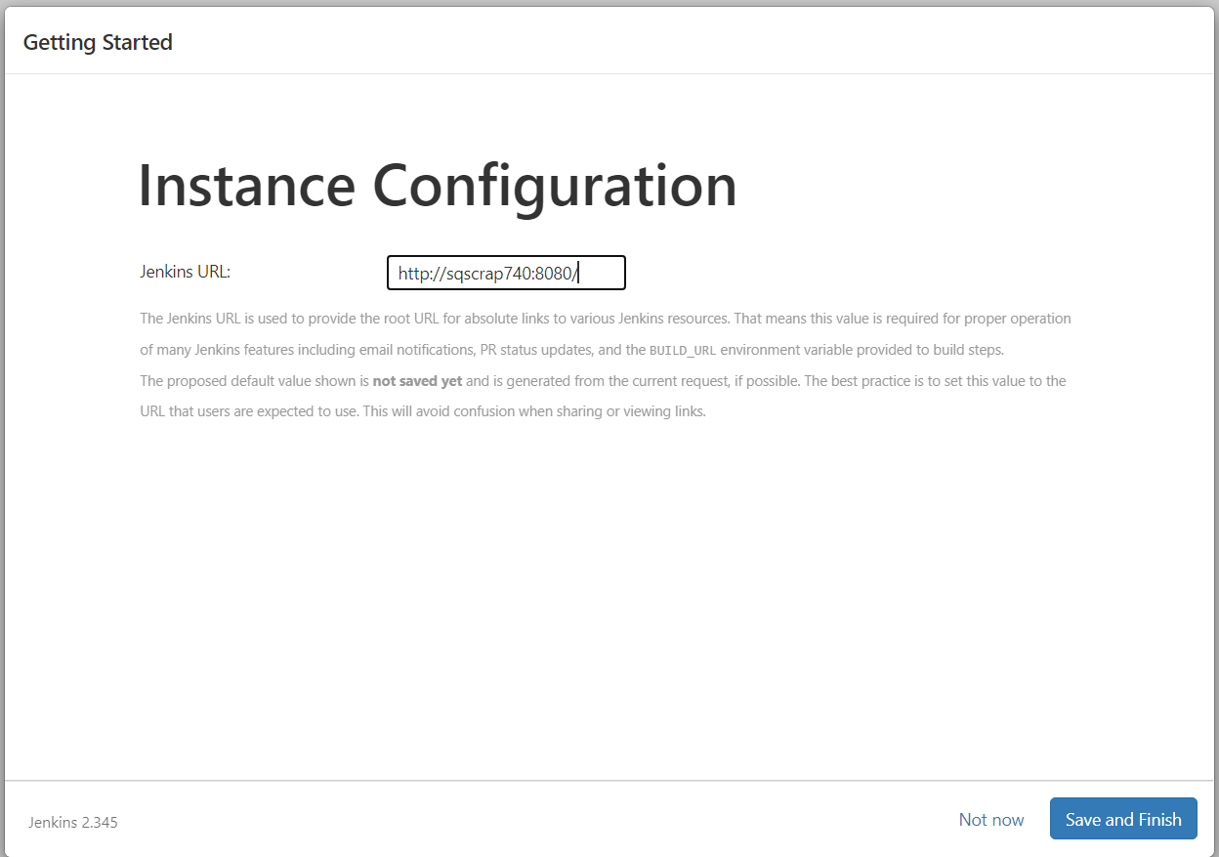

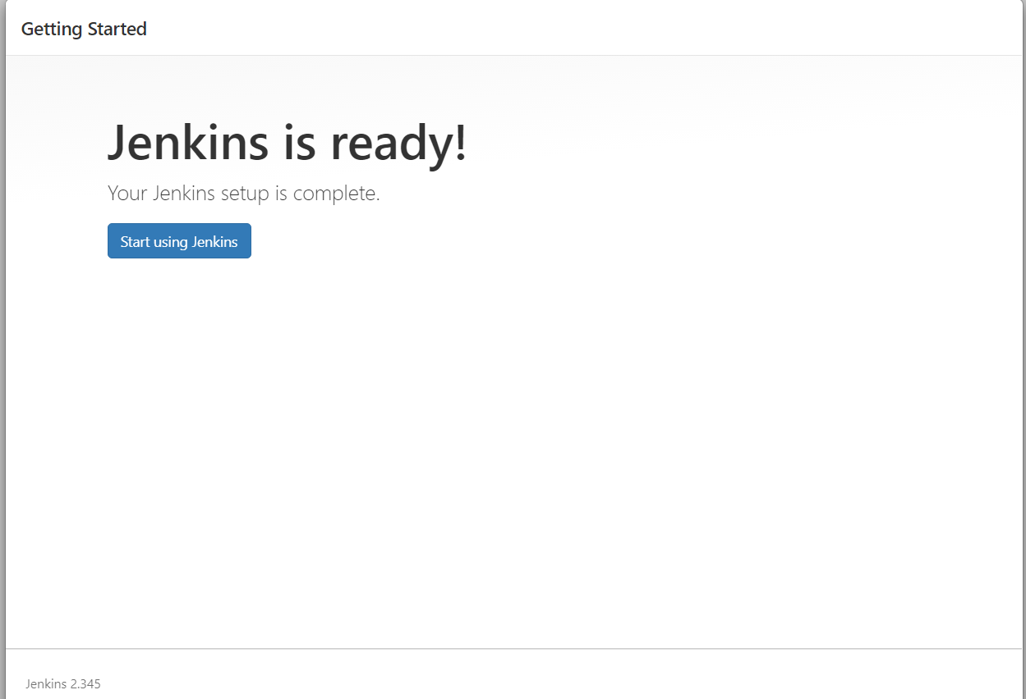
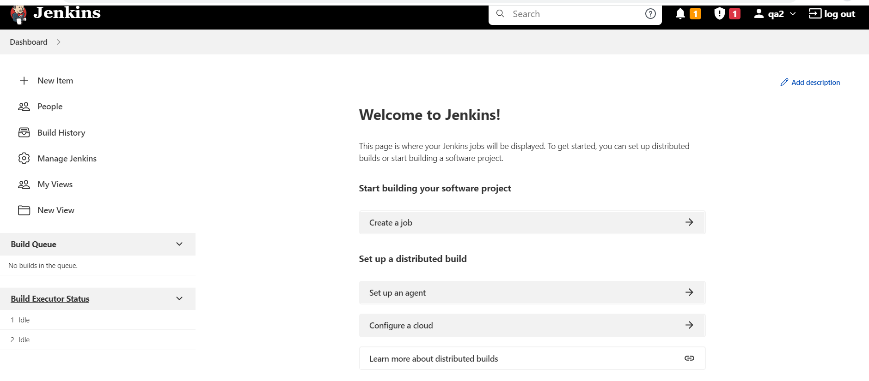
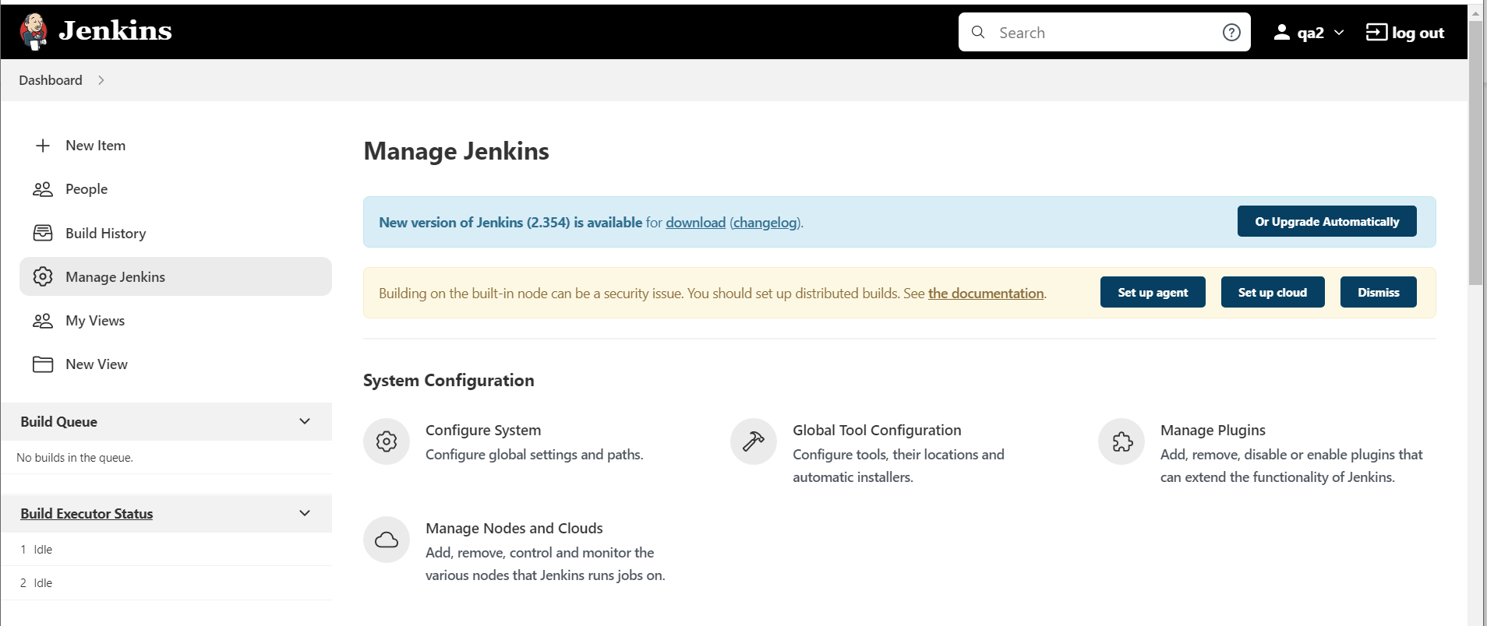

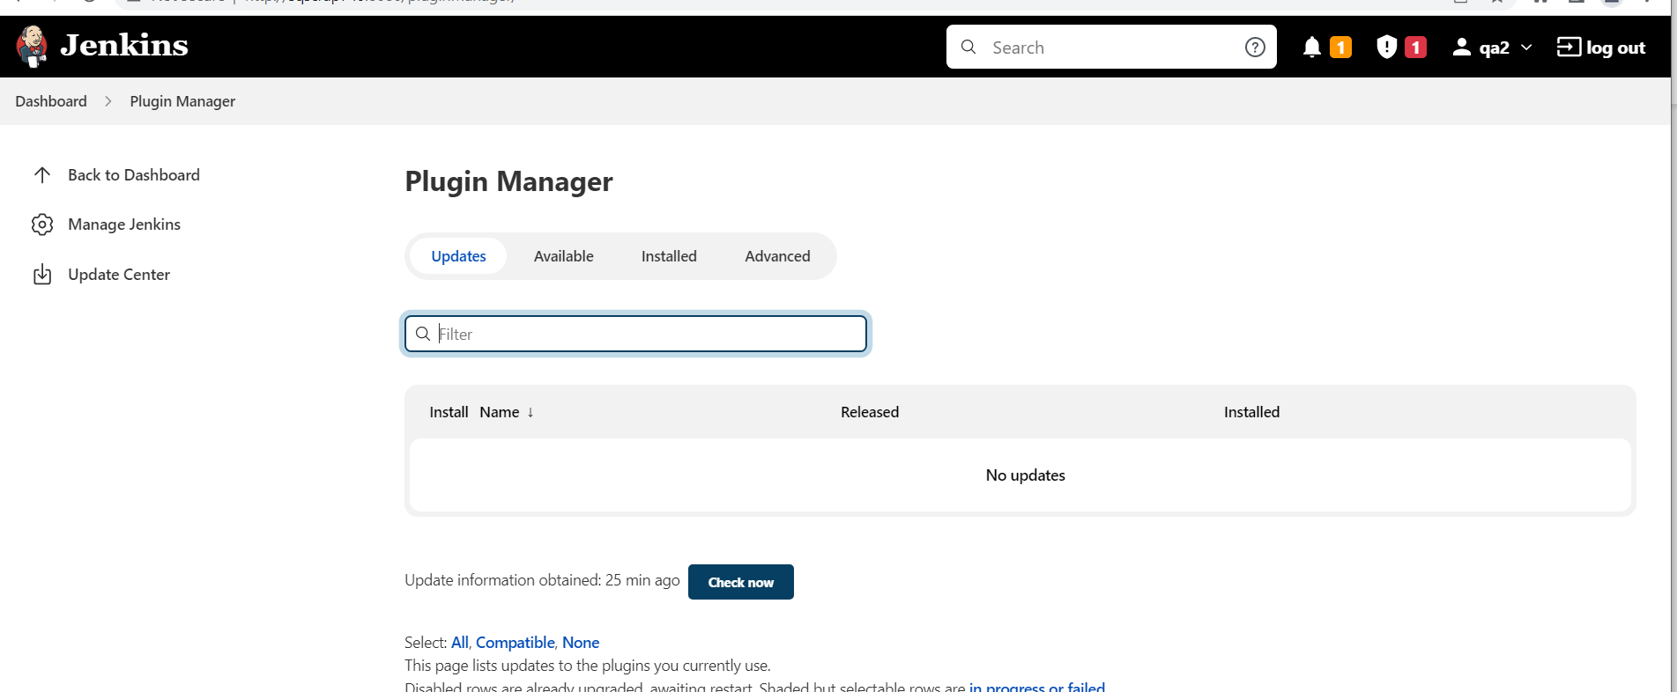

Add documentum xcp , maven related plugins
Junit , Active Directory , SSH , Publish Over SSH , Dashboard View once all plugins are installed
Go to Jenkins plugins and install
Unleash Maven
Maven Release Plug-in
Maven Metadata Plugin for Jenkins CI server
Pipeline Maven Integration
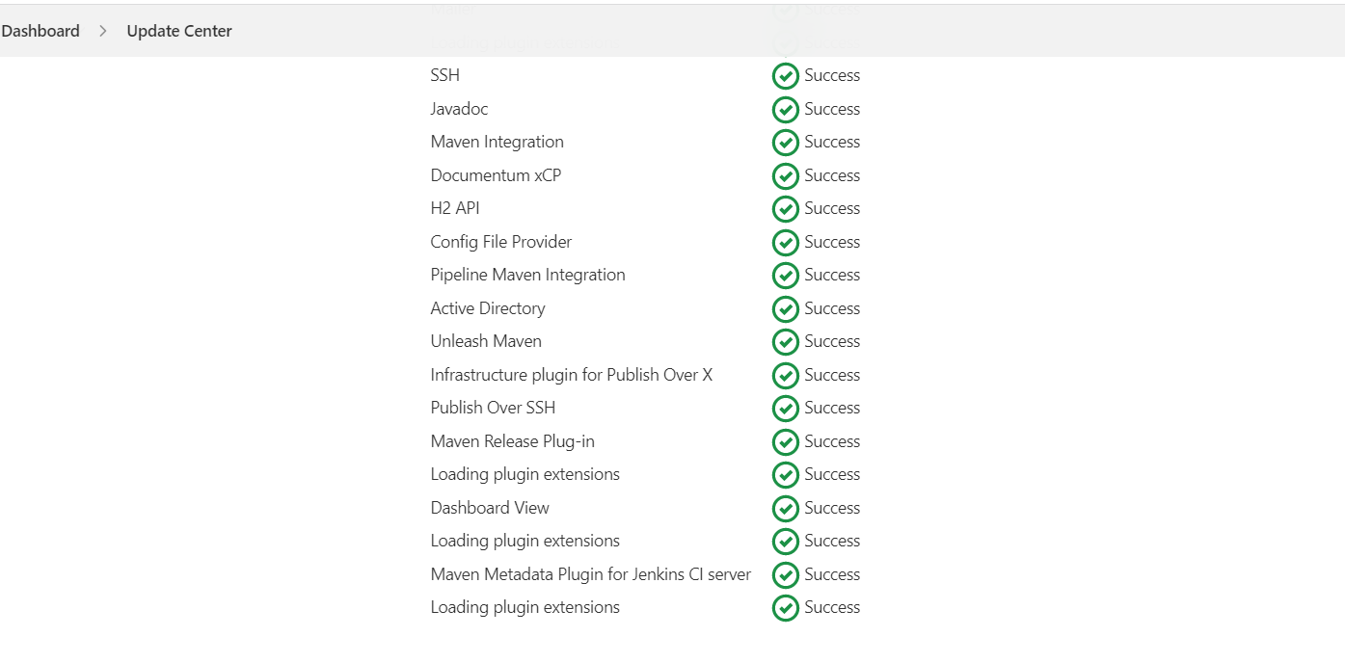

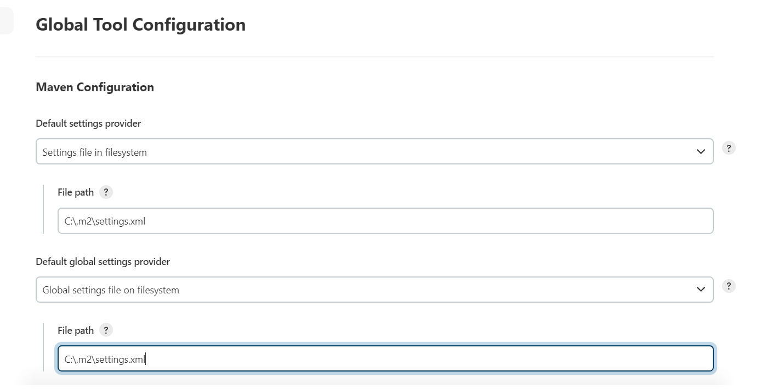

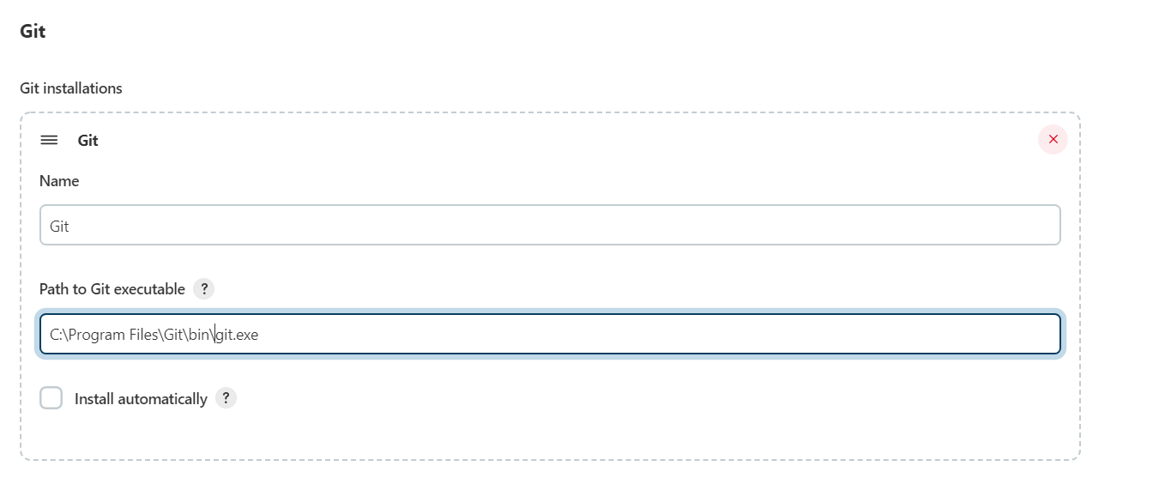

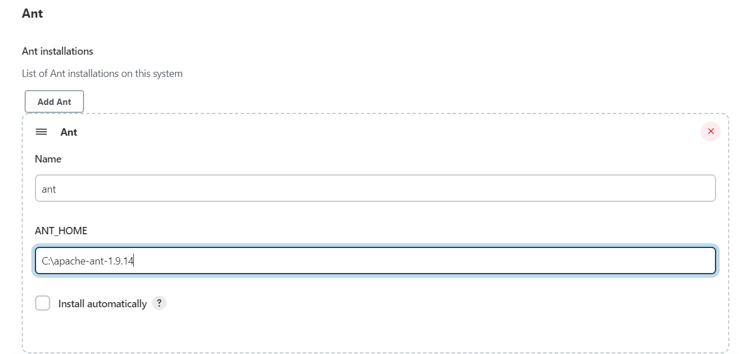
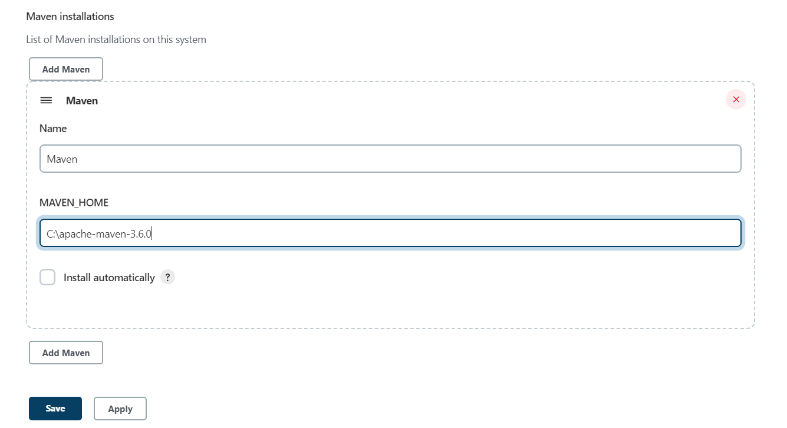

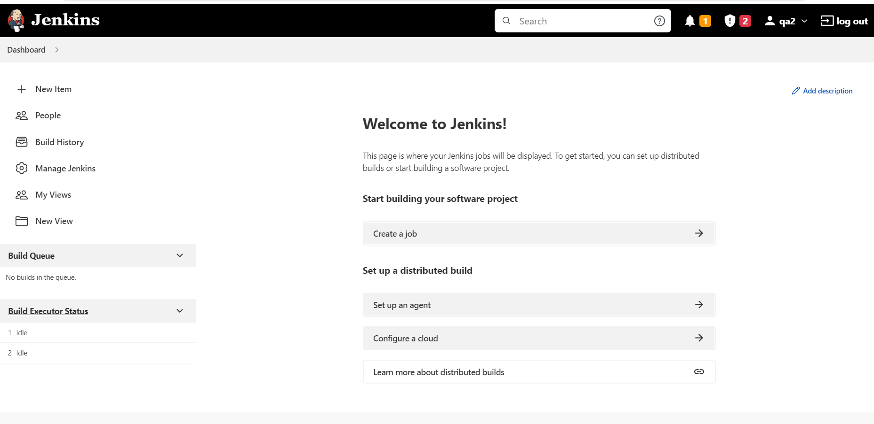

- Sencha Installation:
- Uninstall old version of Sencha.
- Install the new version of Sencha.

